**Name: Sadaqat Hussain**

**Reg no: sp20-bse-058**

**Ecommerce website**

**SUMMARY:**

**eCommerce website**

**Summery:**

**Introduction of e-commerce:**

E-commerce is a means of conducting business, where the buying or selling of goods and services or the transmitting of funds or data, occur via electronicmedium. There are no physical market places and the entire process of marketing and selling of goods, takes place on-line or electronically.

**Main activities of e-commerce:**

Online shopping for retail sales direct to consumers via Web sites and mobile apps, and conversational commerce via live chat, chatbots, and voice assistants. Providing or participating in online marketplaces, which process third-party business-to-consumer or consumer-to-consumer sales.

**Scope of E-Commerce:**

* Selling can be focussed to the global customer
* Pre-sales, subcontracts, supply
* Financing and insurance
* Commercial transactions: ordering, delivery, payment
* Product service and maintenance
* Co-operative product development
* Distributed co-operative working
* Use of public and private services
* Business-to-administrations (e.g. customs, etc)
* Transport and logistics
* Public procurement
* Automatic trading of digital goods
* Accounting
* Dispute resolution

**objective of a website:**

Marketing drive traffic, engage prospects, generate leads and re-engage existing customers. Sales help close sales by validating and supporting sales team communications. Customer Support improve customer satisfaction through better service. Webmasters simplify and optimize content updates and website management.

**User goal:**

User Goals are descriptions of end states that users want to reach. ... Example user goals could be getting into college, learning a to bake cookies, or becoming a licensed driver. Web sites and applications are most useful when they are designed with an understanding of the user's (and site creator's) larger context

**How E-Commerce Works:**

The consumer first moves through the internet to the merchant’s web site. At the web site, the consumer is briefly given an introduction to the product or services the merchant offers. It is at this point that the consumer makes the decision to visit the web store by clicking on a link or button located on the web page (e.g., Buy Now, Shop Online, or an image of a shopping cart button are common entry points into a web store). After choosing to visit the web store, the consumer is typically connected to an online transaction server located somewhere else on the internet which runs software commonly referred to as a shopping cart application. The shopping cart application has been setup by the merchant to display all products and services offered, as well as calculate pricing, taxes, shipping charges, etc.

From there, the consumer decides that he wants to purchase something, so he enters all pertinent credit card information and a sales order is produced. Depending on the ecommerce implementation, the sales order can now take two totally different paths for confirming to the consumer that the order is officially placed.

**Scenario 1:**

The consumer’s credit card information goes directly through a private gateway to a processing network, where the issuing and acquiring banks complete or deny the transaction. This generally takes place in no more than 5-7 seconds and the consumer is then informed that the order was received, the credit card was authorized, and that the product will ultimately be shipped.

**Scenario 2:**

The consumer’s entire order and credit card information is electronically submitted back to the merchant’s server (usually via email, FTP, or SSL connection) where the order can be reviewed first and then approved for credit card authorization through a processing network. The consumer then receives an email shortly afterwards, confirming the order being received, the credit card being authorized, and status on when the product will exactly be shipped.

In both scenarios, the process is transparent to the consumer and appears virtually the same. However, the first scenario is a more simplistic method of setting up a shopping cart application and does not take into consideration any back office issues that may delay shipment (i.e., items out of stock, back orders, orders submitted after office hours or during holidays, etc.). ManageMore’s eCommerce Manager relies on the second scenario to handle all of its ecommerce orders. This second scenario keeps the consumer accurately informed throughout the entire ordering process.

Let us assume an ecommerce implementation that uses the second scenario mentioned above.

There are several basic steps you will need to accomplish before becoming Commerce enabled.

1. Getting a Merchant Bank Account
2. Web Hosting
3. Web Design Considerations
4. Registering a Domain Name
5. Obtaining a Digital Certificate

**Use cases of search items:**

**Use case diagram:**

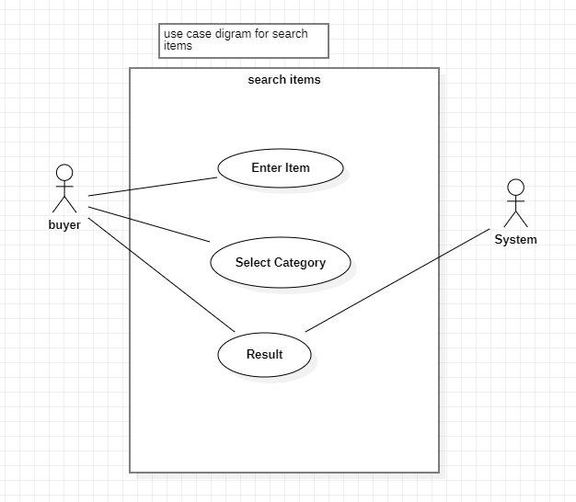

**Fully dressed use case:**

|  |  |
| --- | --- |
| **Name** | Search Item |
| **Scope** | We will modify functionalities when new functionality come into market. |
| **Level** | Items will be displayed when entered keyword is correct. |
| **Primary Actor** | Buyer |
| **Stakeholder and Interests** | Buyer, seller, system |
| **Preconditions** | Entered keywords must be valid |
| **Post conditions** | If keyword is valid items will be displayed |
| **Main success scenario** | Results will be displayed against entered keywords |
| **Extensions** | Entered keywords should be valid than item show |
| **Special requirements** | System must respond in short time |
| **Frequency of Occurrence** | Every time user wants to buy something |
|  |  |

**SSD diagram:**

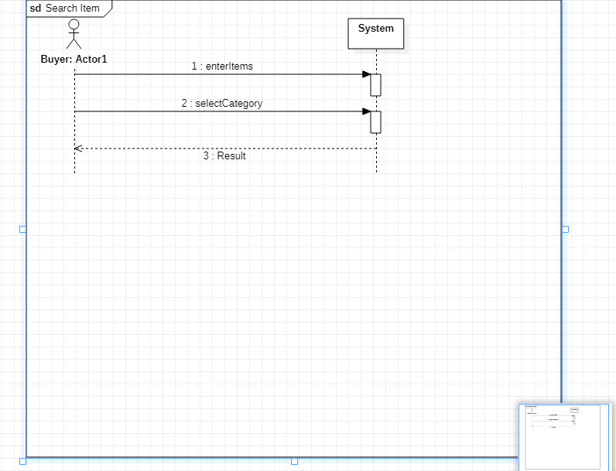

**Operational Contract:**

|  |  |
| --- | --- |
| **Operation** | User has to enter keywords of the required product or choose from category fields to search for desired items |
| **Cross Reference** | Search item |
| **Pre-Condition** | Keywords must be valid |
| **Post-Condition** | Items will be displayed against keywords |

**Select Category:**

|  |  |
| --- | --- |
| **Pre-Condition** | Category should be selected |
| **Post-Condition** | Items will be displayed when category will selected |
|  |  |
|  |  |

**DESCRIPTION**:

Seller will login to his/her seller account than he/she will go to the product category and will search for new product his/her job is to find the products the user is looking for by matching the user's search keywords with the products in your store. When customers use slang words to describe products and abbreviations or symbols in search.

Seller its over choice to choose different product checking quality .and it is very easy to search items checking quality .easy to dealing.

CUMINCATION DIAGRAM:

